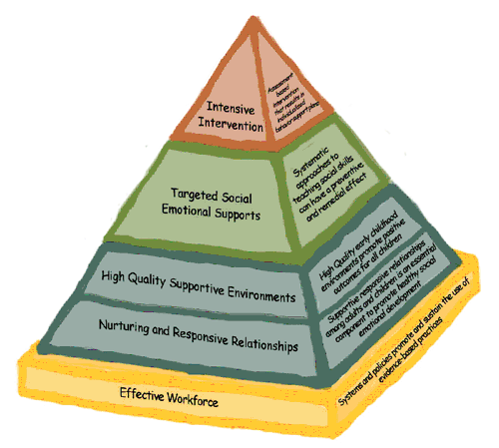
WI Pyramid Model Social Emotional Training

CESA 12 Conference Center

March 19-20, 2012

Registration: 8:30 AM-9:00 AM

Training: 9:00 AM to 3:30 PM

Overview
Do you have challenging behaviors from the children you work with? Through this training we will focus on providing social emotional supports in the classroom to help children expand their social emotional development and reduce challenging behavior. This approach is an age-appropriate way to implement Positive Behavior Supports (PBIS) with young children. It uses a pyramid model approach, in which we will be covering the 1st and 2nd level of the pyramid, based off of the Center for Social Emotional Foundations of Early Learn.

Participants will look at their current practices, new ideas and practices they can implement, and have the chance to network with other professionals around this topic.

Presenter

Stephanie Lulich, CESA 12 Early Childhood Program Support
Sue Erickson, CESA 12 Early Childhood Program Support

Wisconsin State Performance Plan Indicators & Standards Addressed

Wisconsin's State Performance Plan Indicators: 6,7
Wisconsin Teacher Standards Addressed: 1,2,3,4,5,6

Target Audience
Early Childhood Teachers
4 Year-Old Kindergarten Teachers
Child Care Teachers & Directors
Head Start Teachers & Directors
Anyone who works with preschool age children concerned about challenging behavior

Early Bird Registration: (Before Monday, March 5, 2012)

$25 per participant for both days

Regular Registration Fee: (After Monday, March 5, 2012)

$30.00 for both days

This professional development opportunity is supported through funding from the IDEA Preschool Discretionary Project #12-74-9912 – PIDEA60 (CFDA #84.173)

Registration fee includes materials, break and lunch

Deadline for Registration: March 12, 2012

**Viterbo Credit Available**

Please register by going to: www.myquickreg.com

(Registration canceled after registration deadline will not be refunded)

